Understanding Survey Data: Digital Consultation with the Himamaylan City Youth

Executive Summary:
Himamaylan City, in partnership with Makati Business Club and The Asia Foundation, conducted an online consultation with its youth constituents to identify which SK projects should be prioritized and funded by the local government. The digital consultation lasted from September 7 until September 30, 2022, in wherein a total of 455 voters in Himamaylan City participated.
After the data collection process, the survey data collected has undergone a data-science and Natural Language Processing (NLP) approach to analyze and gain insights from the data. In the analysis of the vote, the most voted program per category is as seen below:
- PROJECT HULAT: comprehensive educational campaign on reproductive health
- Eskolar ni SK: Financial assistance to cover miscellaneous school expenses
- Youth Leadership Summits
- "Basura Mo, Premyo Mo" drive
In the analysis of the most frequent words obtained from the open-ended question, (2) classes were established: concerns of the participants and suggestions of the participants. The key concerns are teenage pregnancy, mental health issues, and drug problems. On the other hand, the suggestions are mental health awareness campaign and student educational assistance. To support the insights mined, thematic analysis using the Gibbs Sampling Dirichlet Multinomial Mixture (GDSMM) has been conducted. From the analysis, (5) central themes were obtained in which teenage pregnancy, mental health awareness, and educational assistance were also mentioned added with topics including education crisis and SK programs that help the youth.
The bigram network analysis also explains the co-occurrence of the term ‘issues’ with teenage pregnancy, mental health issues, and drugs and alcohol addiction which further supports the results of the initial analyses. In conclusion, the main concerns affecting the Himamaylan youth and its program suggestions obtained from each analysis are consistent.

Backgrounds of The Survey:
Himamaylan City conducted a digital consultation with its youth constituents to identify which SK projects should be prioritized and funded by the local government. The survey results will benefit the local government in preparing, implementing, and initiating plans, programs, and activities for the youth.
Objectives of the Survey:
- Identify the top-voted SK programs and projects per category that should be prioritized and funded by the local government.
- Understand the main concerns of the Himamaylan youth constituents based on their comments;
- Determine underlying issues that are occurring in the Himamaylan community; and,
- Highlight the suggested programs or projects of the Himamaylan youth.

Methodology:
Himamaylan City conducted an online survey targeting youth constituents. Below is the high-level flow of the feedback collection and analysis process.
Feedback Collection Process and Instruments
The primary collection tool used was the website (mbc.com.ph), wherein the respondents answered a survey questionnaire consisting of (3): personal information, program voting, and the open-ended feedback section. The personal information consists of name, age range, gender, highest educational attainment, and the barangay in which the respondent is residing. The program voting section wherein the respondents can rank the SK programs and projects based on their preference. Finally, the open-ended feedback section wherein respondents can write comments about the other issues affecting the youth that should be prioritized.

Feedback Collection Summary
Below is a summary of the feedback collection process:
Target Respondents | Youth Respondents
Opening Citizen Assembly | September 7, 2022
Closing Citizen Assembly | September 30, 2022
Days of Feedback Collection | 23 days
Number of Individual Voters | 455 voters
Number of Statements | 23 statements
Numbers of Qualitative Feedback Received | 393 comments

Metadata: Demographics of the Respondents
Fig 1. Age Range of the Participants | Fig 2. Gender of the Participants
Fig 3. Educational Attainment of the Respondents

Based on the demographics, most of the respondents of this survey are in the age range of 15-18. Regarding gender, more than half, or 64% of the respondents, are female. In the highest educational attainment, most of the respondents, or a total of 284 respondents, are at the college level. Regarding the barangay where the respondents reside, it is evenly distributed, with Poblacion Brgy III having the most respondents.

Voting Analysis
In this analysis, the respondents' votes ranking the priority programs are measured by getting the average mean per program. Survey 1 is the highest priority. Thus, the lower average scores indicate higher priority. The tables below show the result of the voting analysis.
table 1: Health
Rank | SK Programs and Project | Score
1 | PROJECT HULAT: comprehensive educational campaign on reproductive health | 1082
2 | Maintenance of TEENiran Center (youth facility) in the community | 1382
3 | Teen Hubs in schools with high teenage pregnancy cases | 1451
4 | Peer Educators training | 1685
5 | Mental health awareness symposium | 1797
6 | Distribution of hygiene kits | 1862
7 | COVID-19 virtual symposium | 1997

Table 2: Education, Economic Empowerment, Social Inclusion & Equity
Rank | SK Programs and Project | Score
1 | Eskolar ni SK: Financial assistance to cover miscellaneous school expenses | 713
2 | Eskwelanihan Drive: School supplies drive | 1047
3 | Partnership with Alternative Learning System (ALS) | 1300
4 | Livelihood Skills Training Program | 1308
5 | Information and education campaign on the rights of LGBTQIA+ and ethnic minorities | 1662

table 3: Peace-building & Security, Governance, Active Citizenship
Rank | SK Programs and Project | Score
1 | Youth Leadership Summits | 930
2 | Linggo ng Kabataan | 1192
3 | Youth Organization registration program | 1494
4 | Quarterly LYDC Sessions | 1825
5 | Support to Brigada Eskwela | 2023
6 | Sports League | 2235
7 | Sports Clinic for athletes and professional referees

Table 4: Environment
Rank | SK Programs and Project | Score
1 | "Basura Mo, Premyo Mo" drive | 824
2 | Environmental protection and waste management forum | 923
3 | Mangrove, tree planting, and beautification project | 1061
4 | Training and information awareness on environmental hazards and risk assessment | 1212

Based on the respondents' votes, the priority programs per category are shown in Table 5.
Table 5: Top Voted Programs per Category
Program Category | Project Name
Health | PROJECT HULAT: comprehensive educational campaign on reproductive health
Education, Economic Empowerment, Social Inclusion, and Equity | Eskolar ni SK: Financial assistance to cover miscellaneous school expenses
Peacebuilding & Security, Governance, Active Citizenship | Young Leadership Summit
Environment | "Basura Mo, Premyo Mo" drive

Mining Insights from the Qualitative Data
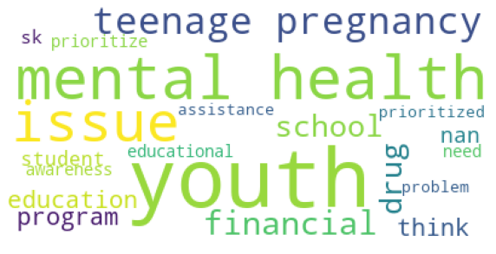
Apart from analyzing the vote, the respondents also added comments in an open-ended format regarding the issues affecting the youth that should be prioritized. From the textual comments, key topics were obtained using Natural Language Processing (NLP).

The figure above shows a word-cloud visualization of the most frequent words in the textual data from the respondents' feedback. The topic mining showed the following key concerns and suggestions.
Category | Label
Suggestions from the Respondents | - Mental Health Awareness  - Student Educational Assistance
Main concerns of the Respondents | - Teenage pregnancy  - Mental Health Issue  - Drug Problems

Thematic Analysis
The Gibbs Sampling Dirichlet Multinomial Mixture (GDSMM) was utilized in this analysis. GDSDMM is a short text clustering model. The model groups words into a cluster similar to each other based on usage and meaning.
This analysis aims to determine the main concerns of the Himamalyan youth constituents, the suggestions, and any underlying themes that can be obtained from the respondents' comments. (2) Thematic analyses have been conducted to obtain insights from both general perspectives and based on gender.
Table 6: The General Perspective
Topic # | Label | Topic Words
0 | Mental Health Awareness | health, mental issues, youth, well-being, awareness
1 | The Teenage Pregnancy Issue | pregnancy, teenage, youth, education, issues, think
2 | Educational Crisis | also, school, trash, youth, literacy, internet
3 | Educational Assistance | none, financial, nan, education, assistance, school
4 | SK youth programs and activities | SK, youth, must, activities, programs, help

The central themes obtained in the general perspective based on the comments are seen in Table 6. The first theme is labeled 'Mental Health Awareness, which is supported by topic words like 'health,' 'mental,' 'issues,' 'youth,' 'well-being,' and 'awareness.' This may entail that the respondent's concern is about mental health and is suggesting programs for its awareness. The second theme is about the 'Teenage pregnancy issue' where words like 'pregnancy,'' teenage,' and 'youth' occurred. Another theme generated from the analysis is the education crisis wherein strong words like 'trash' are seen. This may indicate a problem in the education sector of Himamaylan City. Also, the term 'internet' was seen, which could cite connectivity issues of the students during online class setup. The final two obtained central themes are suggestions to the policymakers and SK leaders, like student financial assistance and programs that can help the youth.
Table 7: The Male Perspective
Topic # | Label | Topic Words
0 | Teenage Pregnancy | youth, teenage, pregnancy, think, education, abuse
1 | Issues and priority needs | youth, literacy, drugs, prioritize, school, need
2 | Student support | school, financial, supplies, support, students, lack

Table 8: The Female Perspective
Topic # | Label | Topic Words
0 | Teenage Pregnancy | pregnancy, teenage, education, issues, youth, sex
1 | Mental Health Awareness | mental, health, youth, issues, issue, awareness,

Compared with the male and female perspectives, the themes obtained from the female demographics are similar to the general perspective. In contrast, an underlying theme was discovered from the male perspective. Aside from the lack of financial support for the students, the term 'drugs' also occurred in the topic words, which might indicate a drug problem based on the male perspective.
Bigram Network Word Co-occurrence Analysis
After applying GSDMM for thematic analysis wherein the themes/topics are already obtained. Bigram analysis was performed, it is conducted to identify the top words that occurred together by frequency from the comments in the open-ended feedback section. This analysis helps reveal the most co-occurring words and gain insights based on the results.
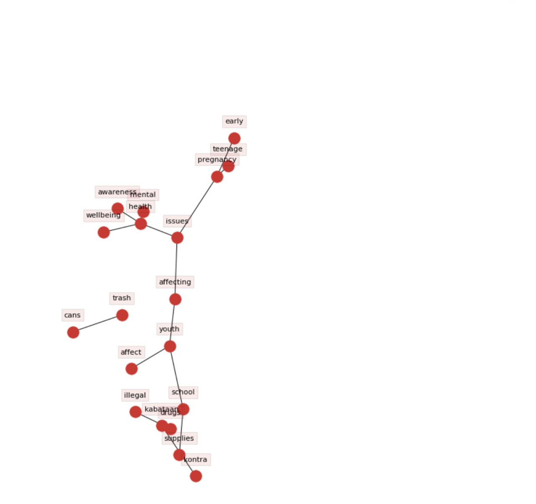
Main Issues of the Himamaylan Youth
Based on the network on the left, there are sub-network that can be seen.
The term 'issues' co-occurred with other groups of words/stories. With that, (3) issues are identified.
- Teenage pregnancy
- The problem of Illegal drugs
- Mental health awareness
The (3) issues identified were also evident in the thematic analysis.

Other concerns of the Himamalyan Youth
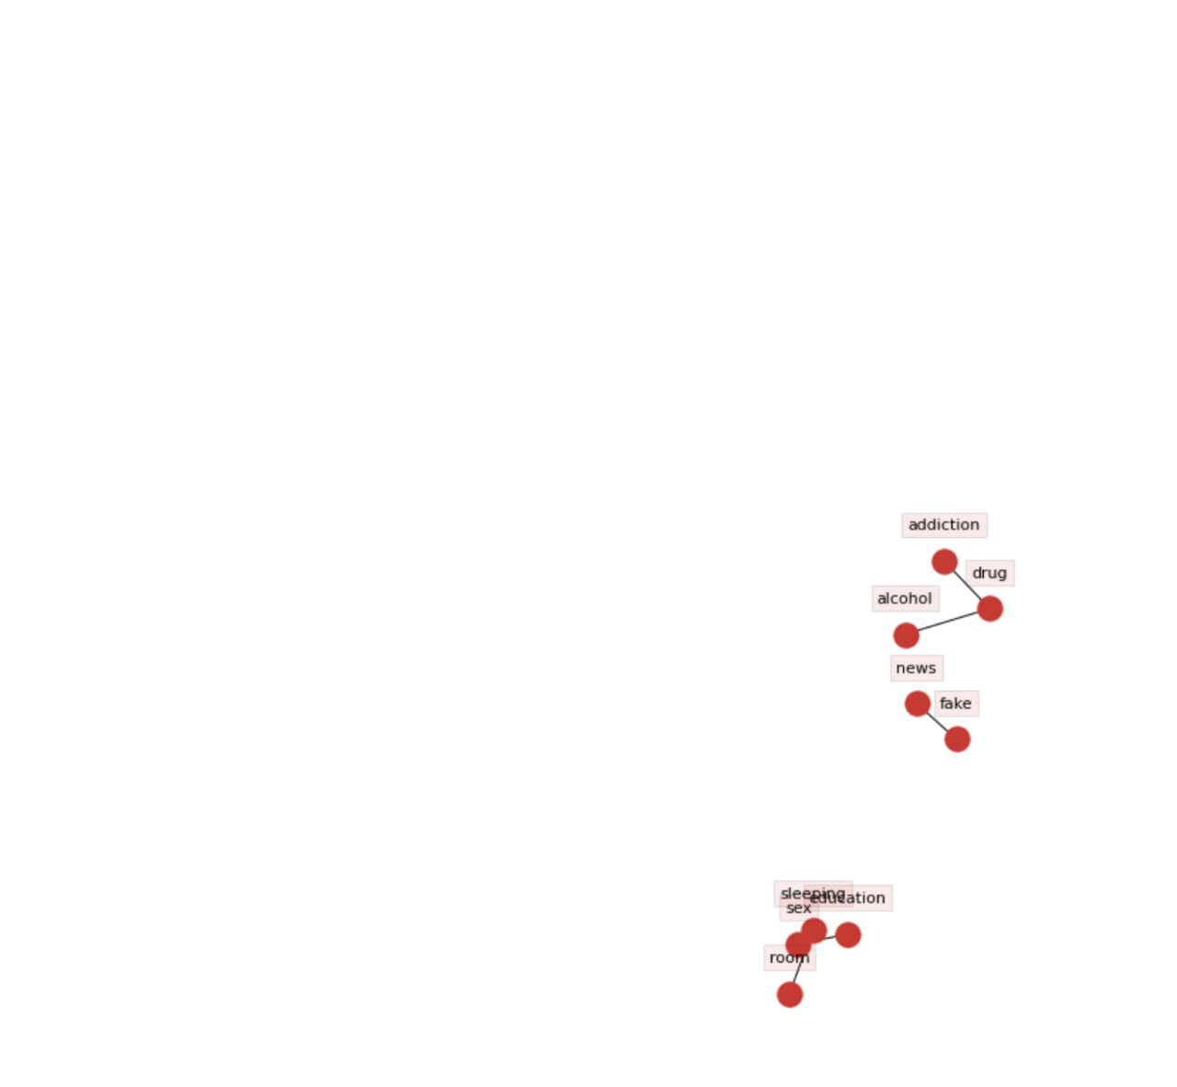
The network on the left shows the other concerns of the Himamaylan youth. First is the concern on addiction which co-occurred with the terms like 'drug' and 'alcohol.' This may entail drug and alcohol addiction in the Himamaylan community. Another concern observed from the respondents' comments is the problem of fake news.
Suggested programs for the Himamaylan youth
In terms of the suggestion of the respondents, the network generated (2) recommended programs based on the inputs of the respondents. First is the educational assistance or financial support to the students. Another one is our tree planting programs.

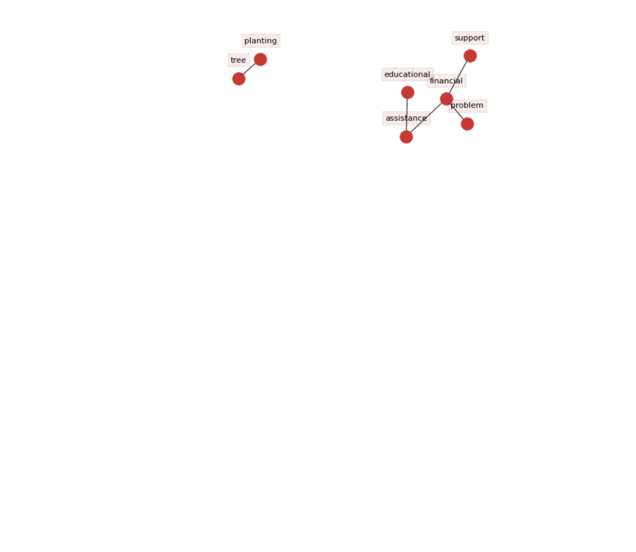
ANALYSTS FOR THIS REPORT:
Myron Darrel Montefalcon, Mideth Abisado
National University National University

Jay Rhald Padilla Ramon Rodriguez
National University National University
END OF REPORT
Revised: 03/10/2022

